Addition and Subtraction Timeline (Numbers in Base Ten)
K | 1st | 2nd | 3rd | 4th | 5th
Add numbers that make 10  Putting together (compose) and taking apart (decompose) ten and some ones using numbers 11-19  dsMentally add one or subtract one from a number less than 20 | Putting together and taking apart 10s and ones  Adding a 2 –digit number to a 1-digit number and a 2-digit number to a multiple of 10 using concrete models, drawing, and place value strategies  Subtracting a multiple of 10 from a multiple of 10  Mentally add 10 and subtract 10 from any number less than 90 | Putting together and taking apart hundreds, tens, and ones  Add and subtract 3 digit numbers within 1,000 using concrete models, drawings and place value strategies  Mentally add and subtract 10 and 100 any number less than 900 | Add and subtract within 1000 using strategies | Use the standard algorithm to add and subtract multi-digit whole numbers | Add and subtract decimals to hundredths, using concrete models or drawings and strategies

Zoom in on First Grade
Putting together and taking apart tens and ones  68  6 tens and 8 ones  68 = 60 + 8  68  60  8  60 + ? = 68  ? + 8 = 68 | 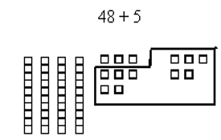  Adding a 2 –digit number to a 1-digit number and a 2-digit number to a multiple of 10 using concrete models, drawing, and place value strategies  8 ones and 5 ones equals 13 ones  13 ones equals 1 ten and 3 ones  The total is 5 tens and 3 ones or 53  8 ones and 5 ones equals 13 ones  13 ones equals 1 ten and 3 ones  The total is 5 tens and 3 ones or 53  8 ones and 5 ones equals 13 ones  13 ones equals 1 ten and 3 ones  The total is 5 tens and 3 ones or 53  8 ones and 5 ones equals 13 ones  13 ones equals 1 ten and 3 ones  The total is 5 tens and 3 ones or 53 | Subtracting a multiple of 10 from a multiple of 10  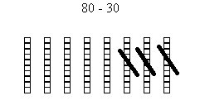  8 tens minus 3 tens  Equals 5 tens  5 ten equals 50 | Mentally add 10 and subtract 10 from any number less than 90  34+  10

